**Installing Python:**

**Step 1)** To download and install Python visit the official website of Python [**https://www.python.org/downloads/release/python-376/**](https://www.python.org/downloads/release/python-376/)**.**

We have chosen Python version 3.7.6.Click -> **Windows x86-64 executable installer.**

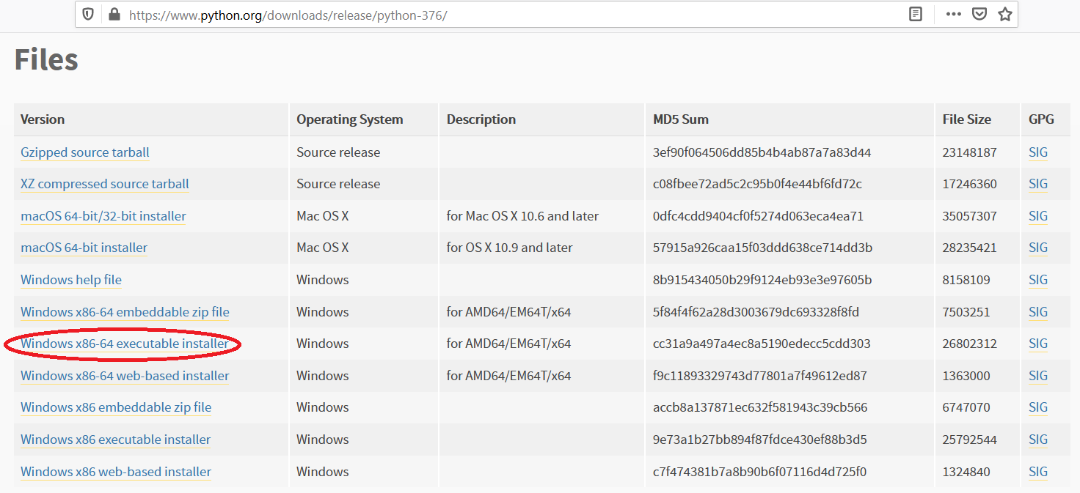

**Step 2)** Once the download is complete, run the exe for install Python. Please select “Add Python 3.7 to PATH”. Now click on Install Now.

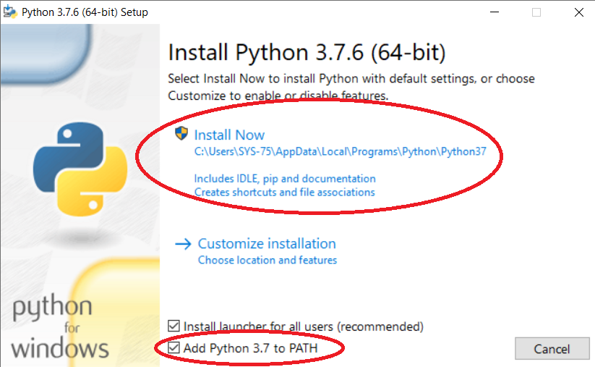

**Step 3)** You can see Python installing at this point.

**Step 4)** When it finishes, you can see a screen that says the Setup was successful. Now click on "Close".

## Installing Pycharm:

## **Step 1)** To download PyCharm visit the website <https://www.jetbrains.com/pycharm/download/other.html>.

## select Version: 2020.3.3

## H:\Programmers\Anitha Jesline\Others\Readme\Pycharm 2020.3.3.png

## ****Step 2)**** Once the download is complete, run the exe for install PyCharm. The setup wizard should have started. Click “Next”.

## https://www.guru99.com/images/Pythonnew/Python2.6.png

## ****Step 3)**** On the next screen, Change the installation path if required. Click “Next”.

## https://www.guru99.com/images/Pythonnew/Python2.7.png

## ****Step 4)**** On the next screen, you can create a desktop shortcut if you want and click on “Next”.

**Step 5)** Choose the start menu folder. Keep selected JetBrains and click on “Install”.

**Step 6)** Wait for the installation to finish.

**Step 7)** Once installation finished, you should receive a message screen that PyCharm is installed. If you want to go ahead and run it, click the “Run PyCharm Community Edition” box first and click “Finish”.

**Step 8)**After you click on "Finish," the Following screen will appear.

